12_Feb_2026@AnkitaSadatpure

Launch instance and connect with rds and springboot

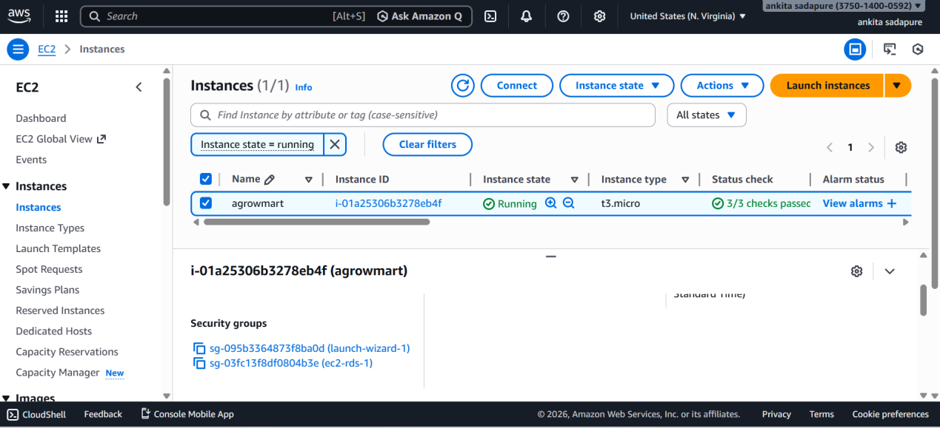

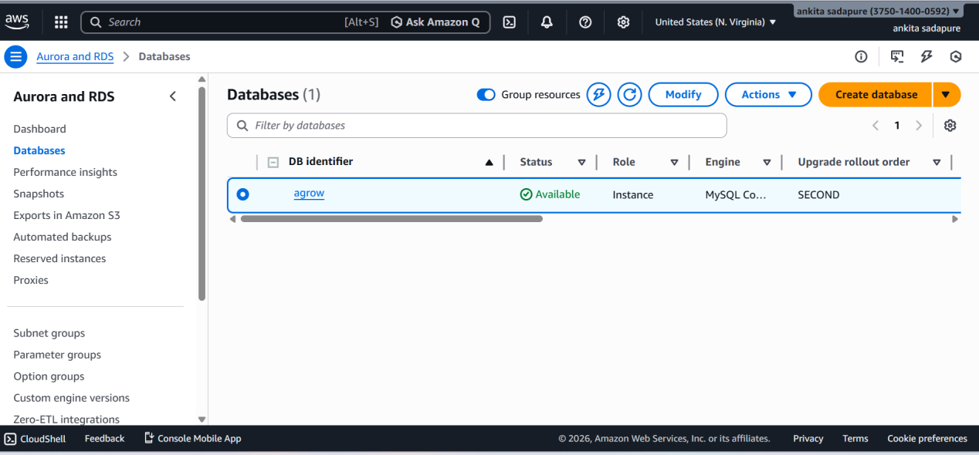
Jar upload in ec2

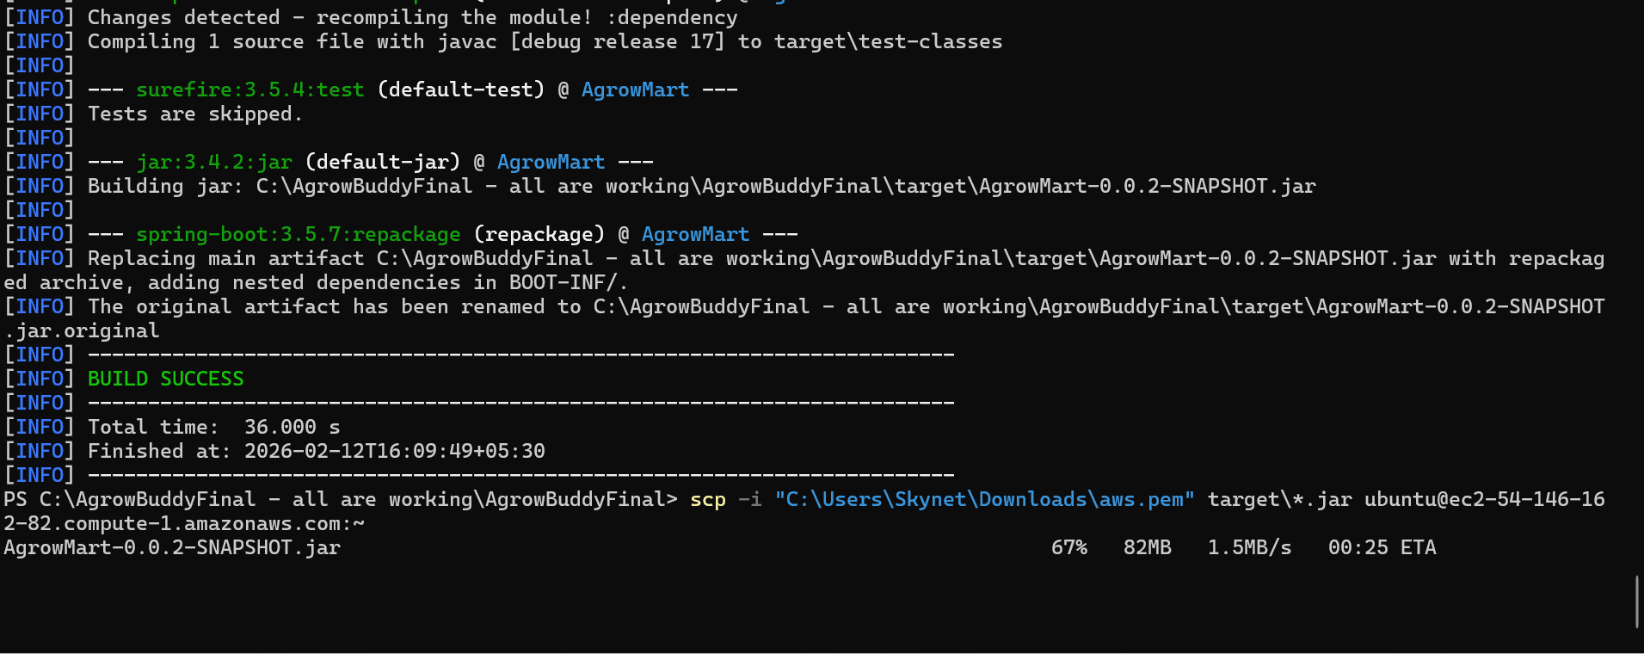

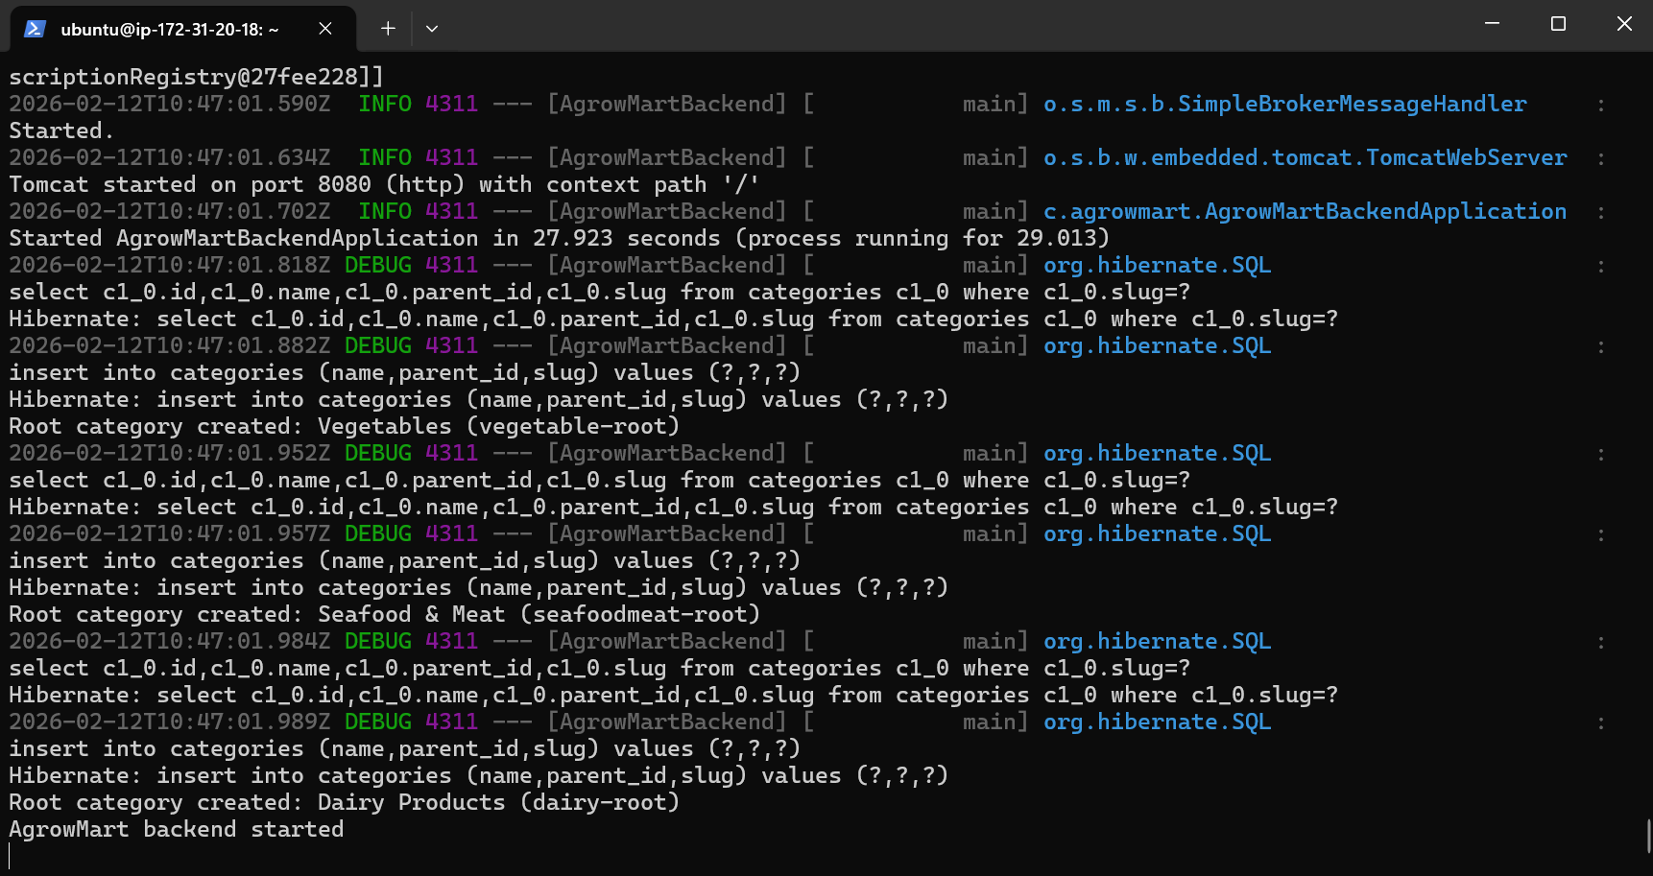

Backend started

Reverse proxy and Ngnix

1. Why We Use Nginx
Nginx is used as a front server that handles requests from users before they reach your application.
It helps because:
- It is fast
- It improves security
- It can handle many users at once
- It manages HTTPS
- It hides your real app server
Think of Nginx as a gatekeeper that controls traffic coming to your app.

2. What is Reverse Proxy?
A reverse proxy is when Nginx receives a request from a user and forwards it to your backend application.
Flow:
User → Nginx → App Server
The user talks to Nginx, not directly to your app.

3. Real Life Example
Hospital example:
Patient → Reception → Doctor
Patient = User
Reception = Nginx
Doctor = Application
The patient never directly goes to doctor. Reception sends them.

4. Simple Nginx Reverse Proxy Config Example
Example configuration:
server {
listen 80;
server_name example.com;
location / {
proxy_pass http://localhost:3000;
}
}
Meaning:
- listen 80 → Nginx listens on port 80
- server_name → your domain name
- location / → apply rule for all requests
- proxy_pass → send request to app running on port 3000

Simple Definition
A reverse proxy is a server (like Nginx) that receives requests from users and forwards them to your backend application.

